**Sunkari Manohar**

**Python Assessment 4 – 15/12/2023**

* Data Structure - Set ()
* Set methods
* Functions
* String Functions

**Set :**

**Set is represented using curly braces {}.**

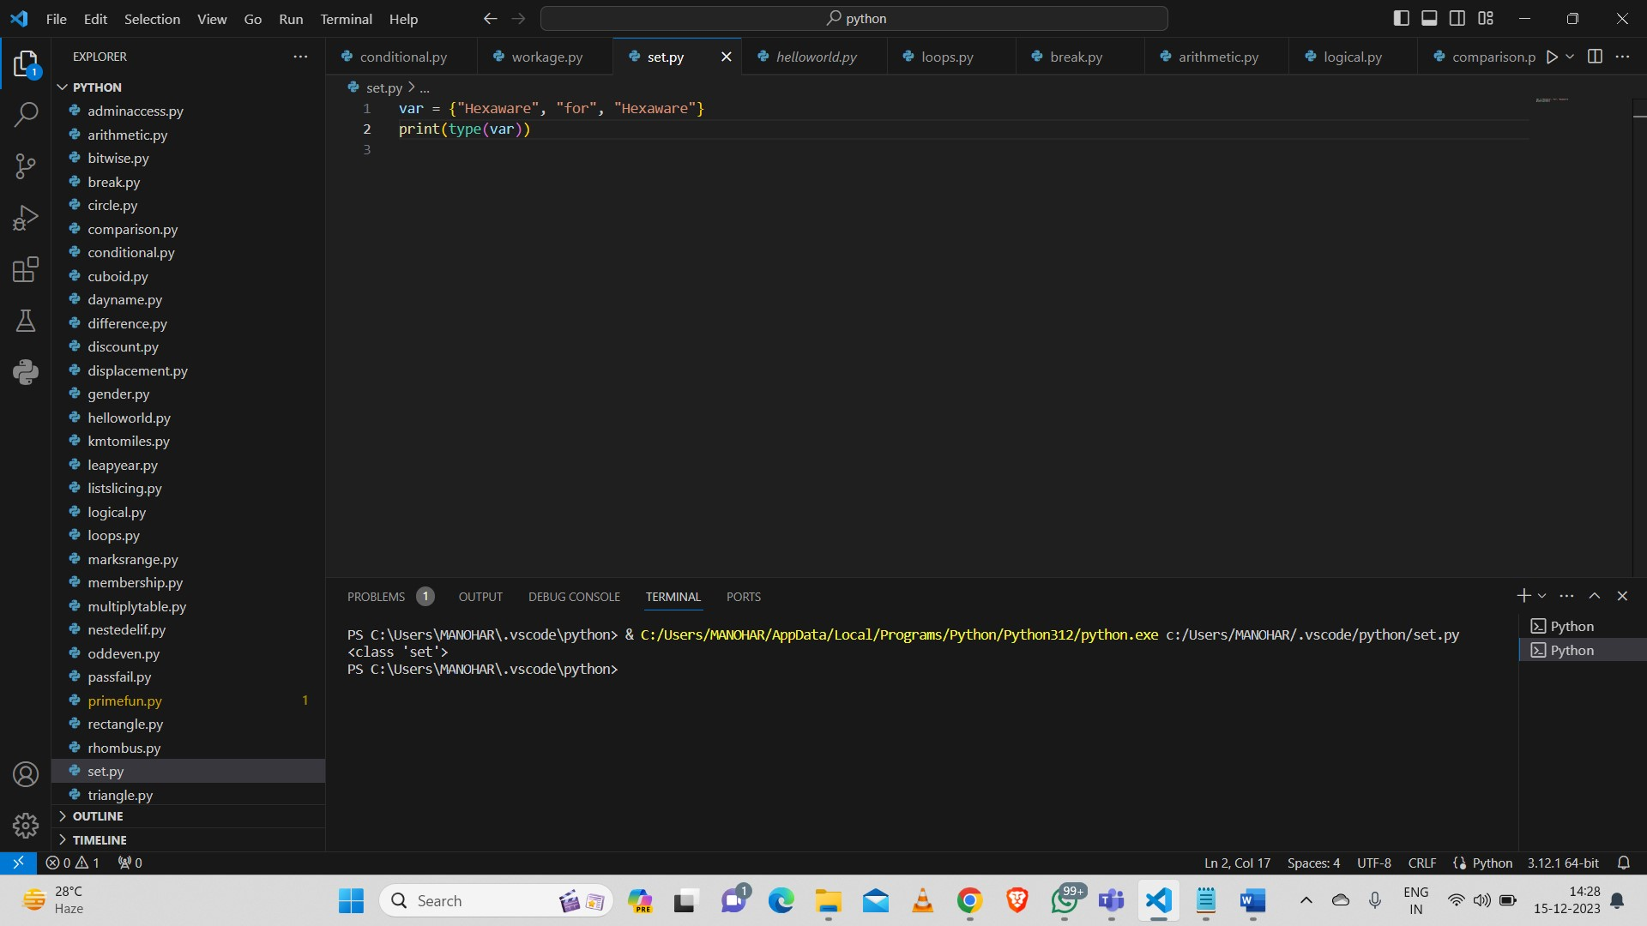

**Set Methods:**

**ADD:**

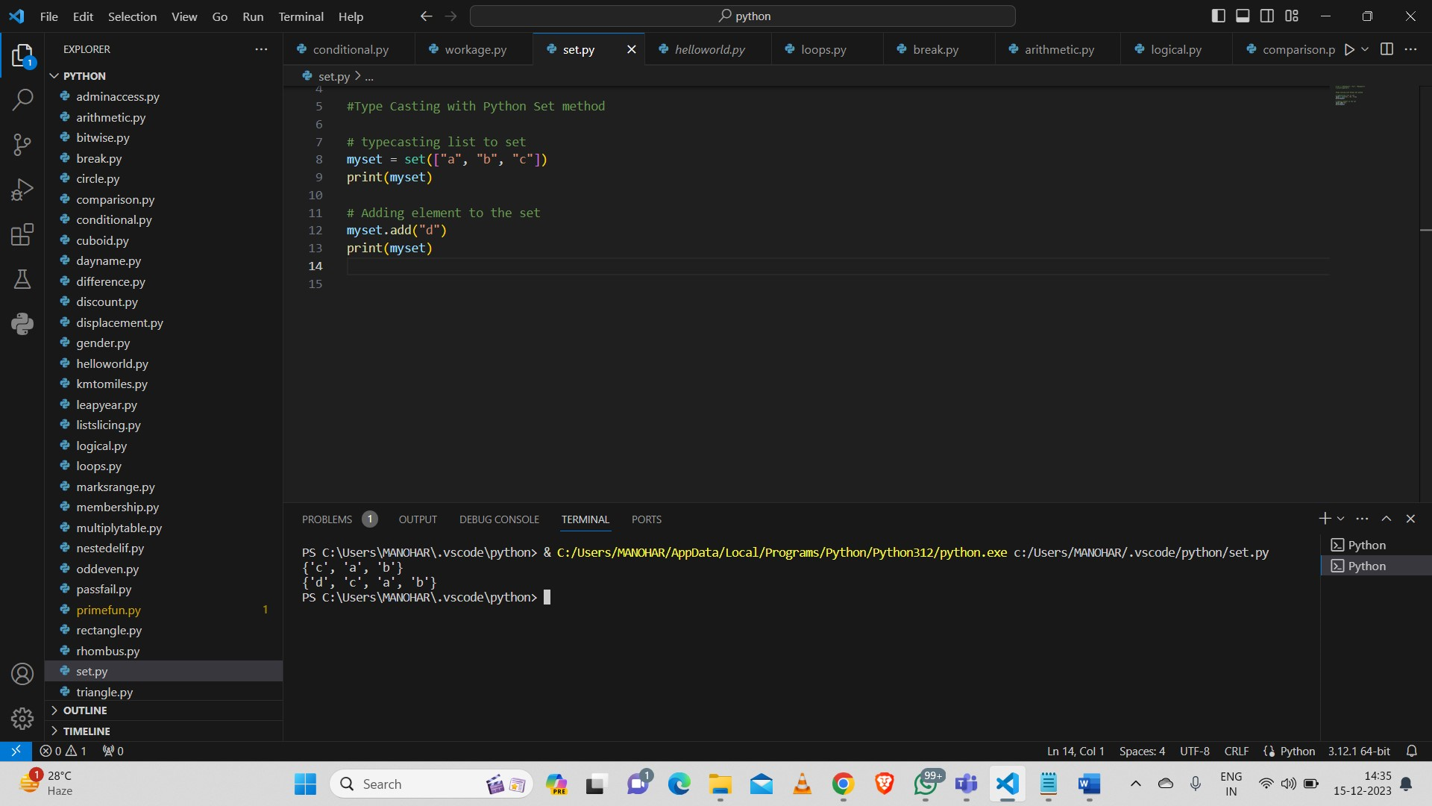

**Union:**

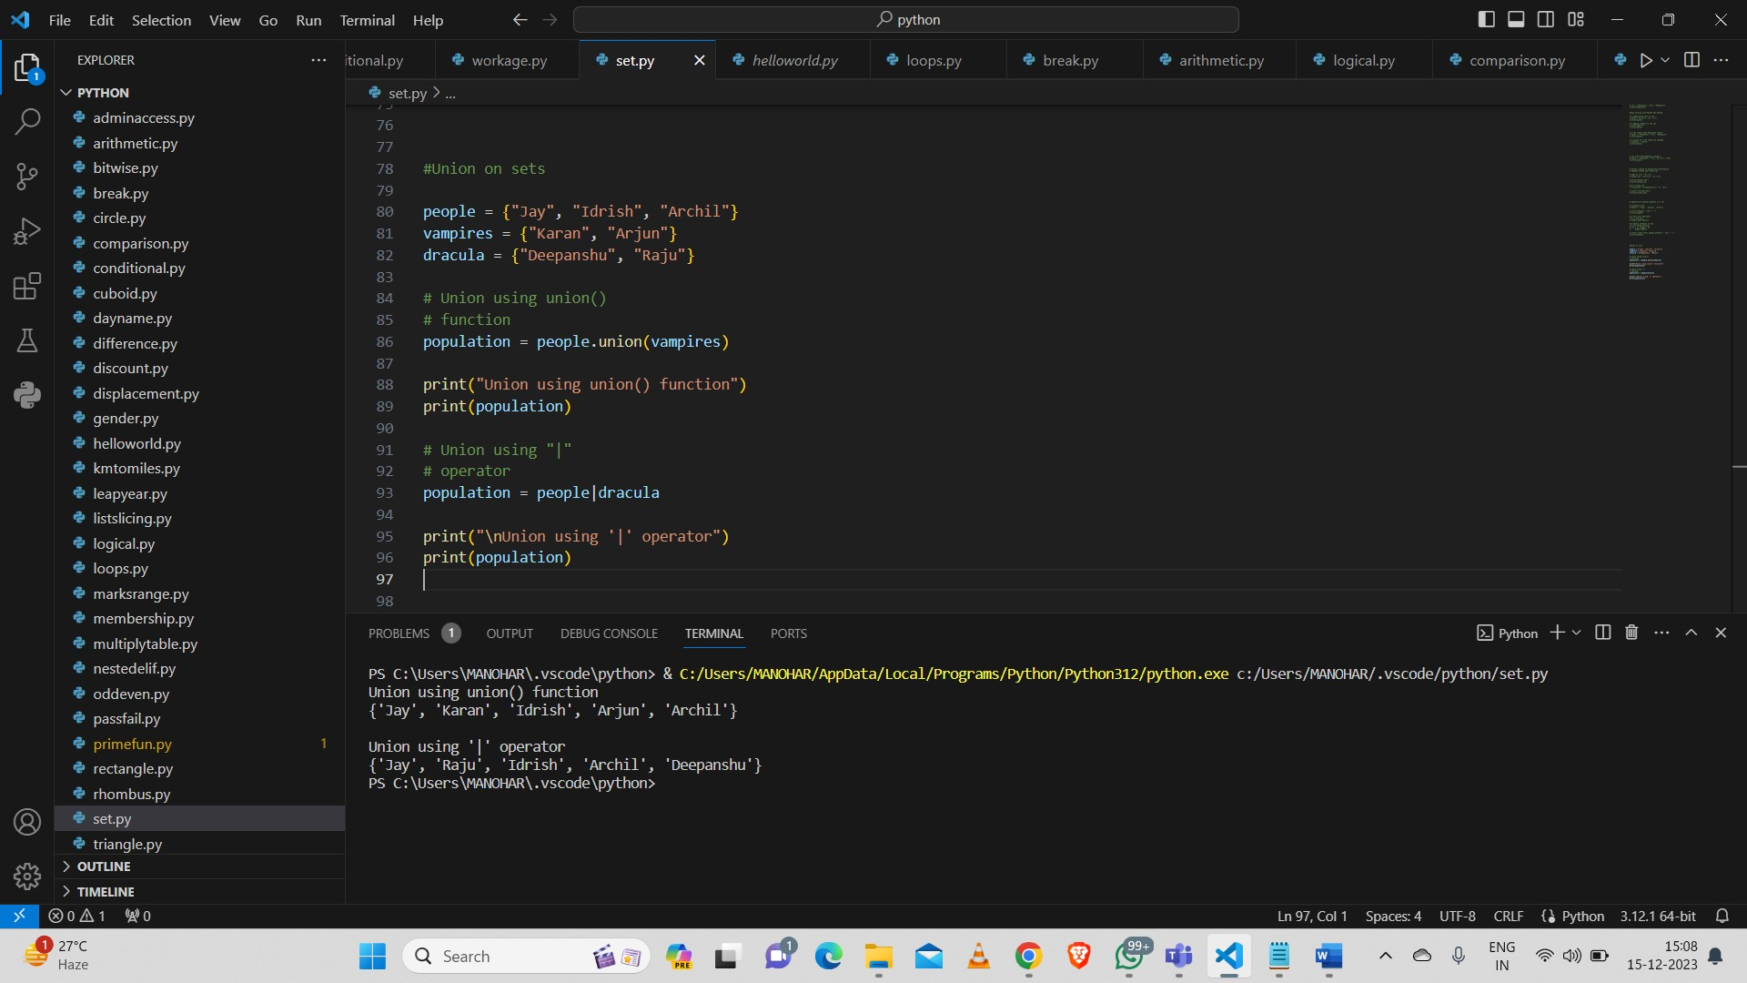

**Intersection:**

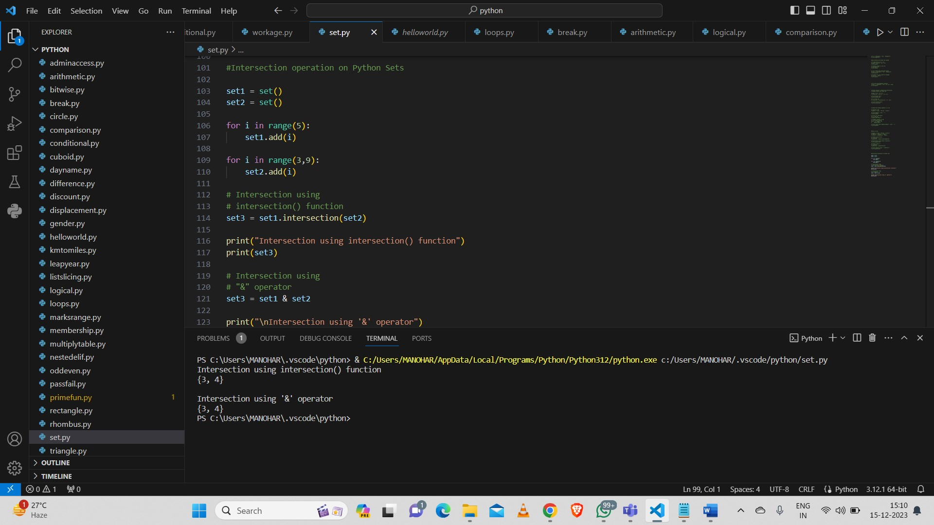

**Difference:**

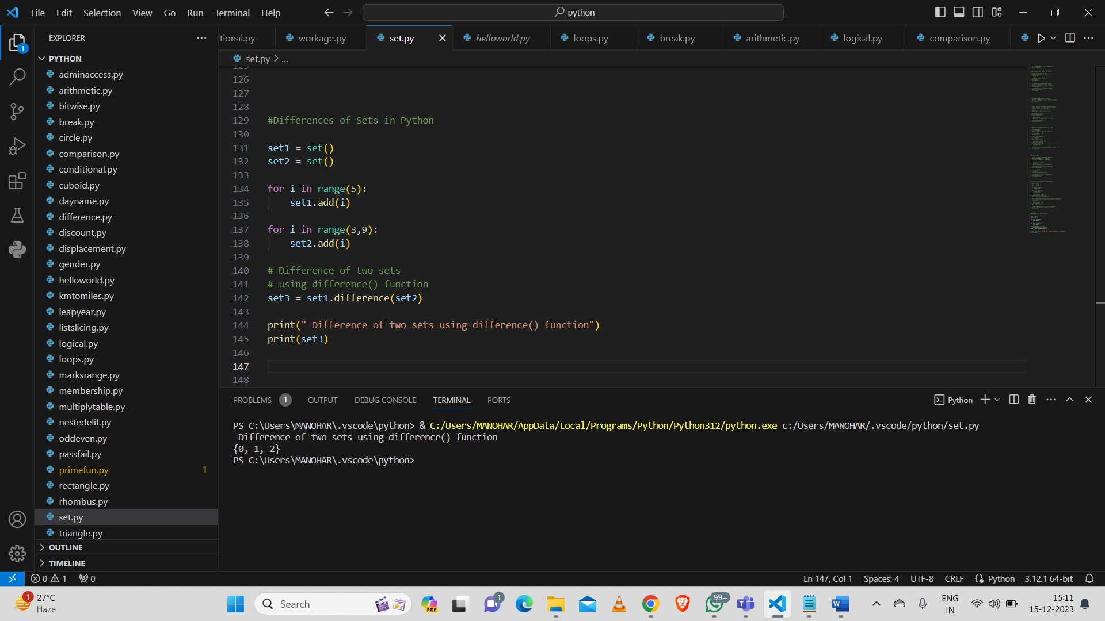

**Clear:**

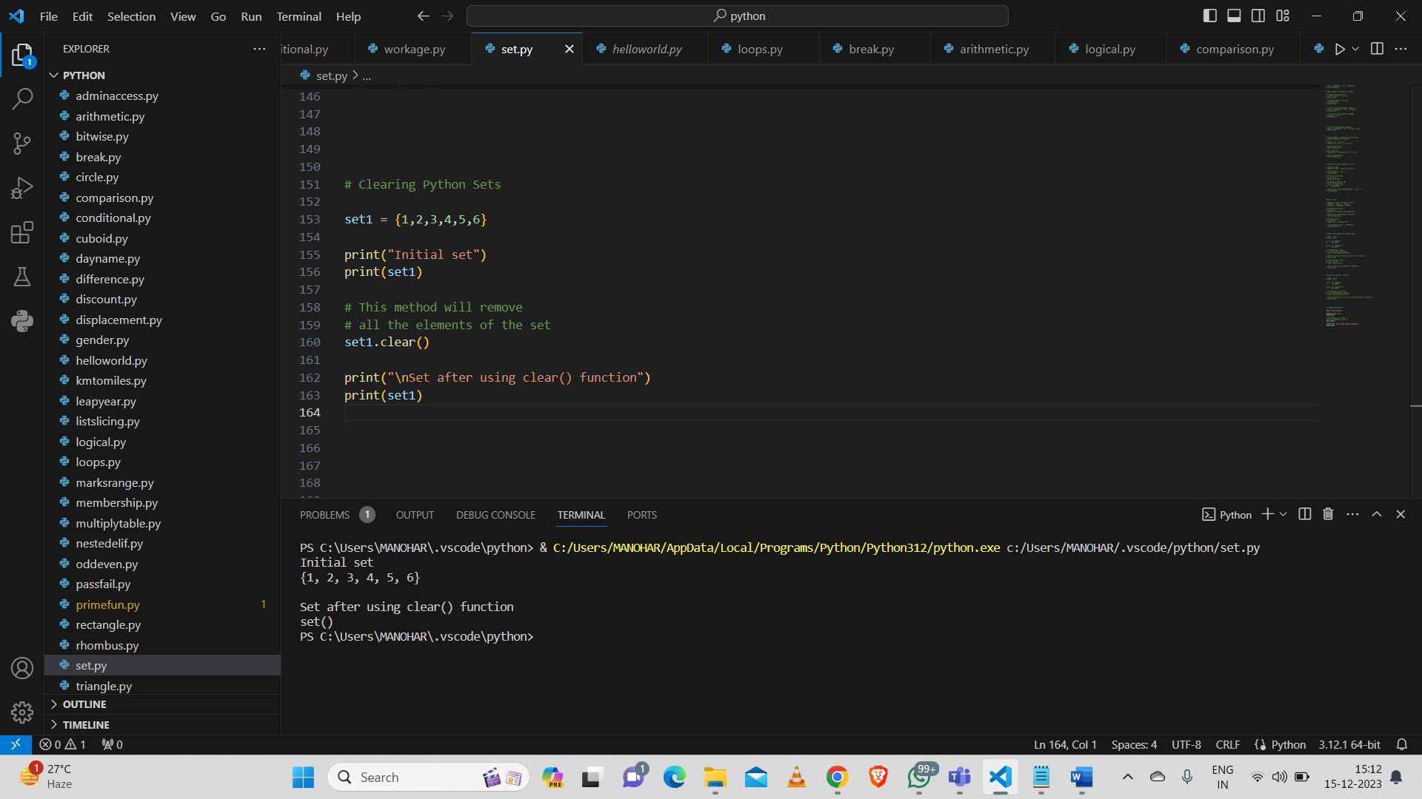

**Discard,remove,pop,clear:**

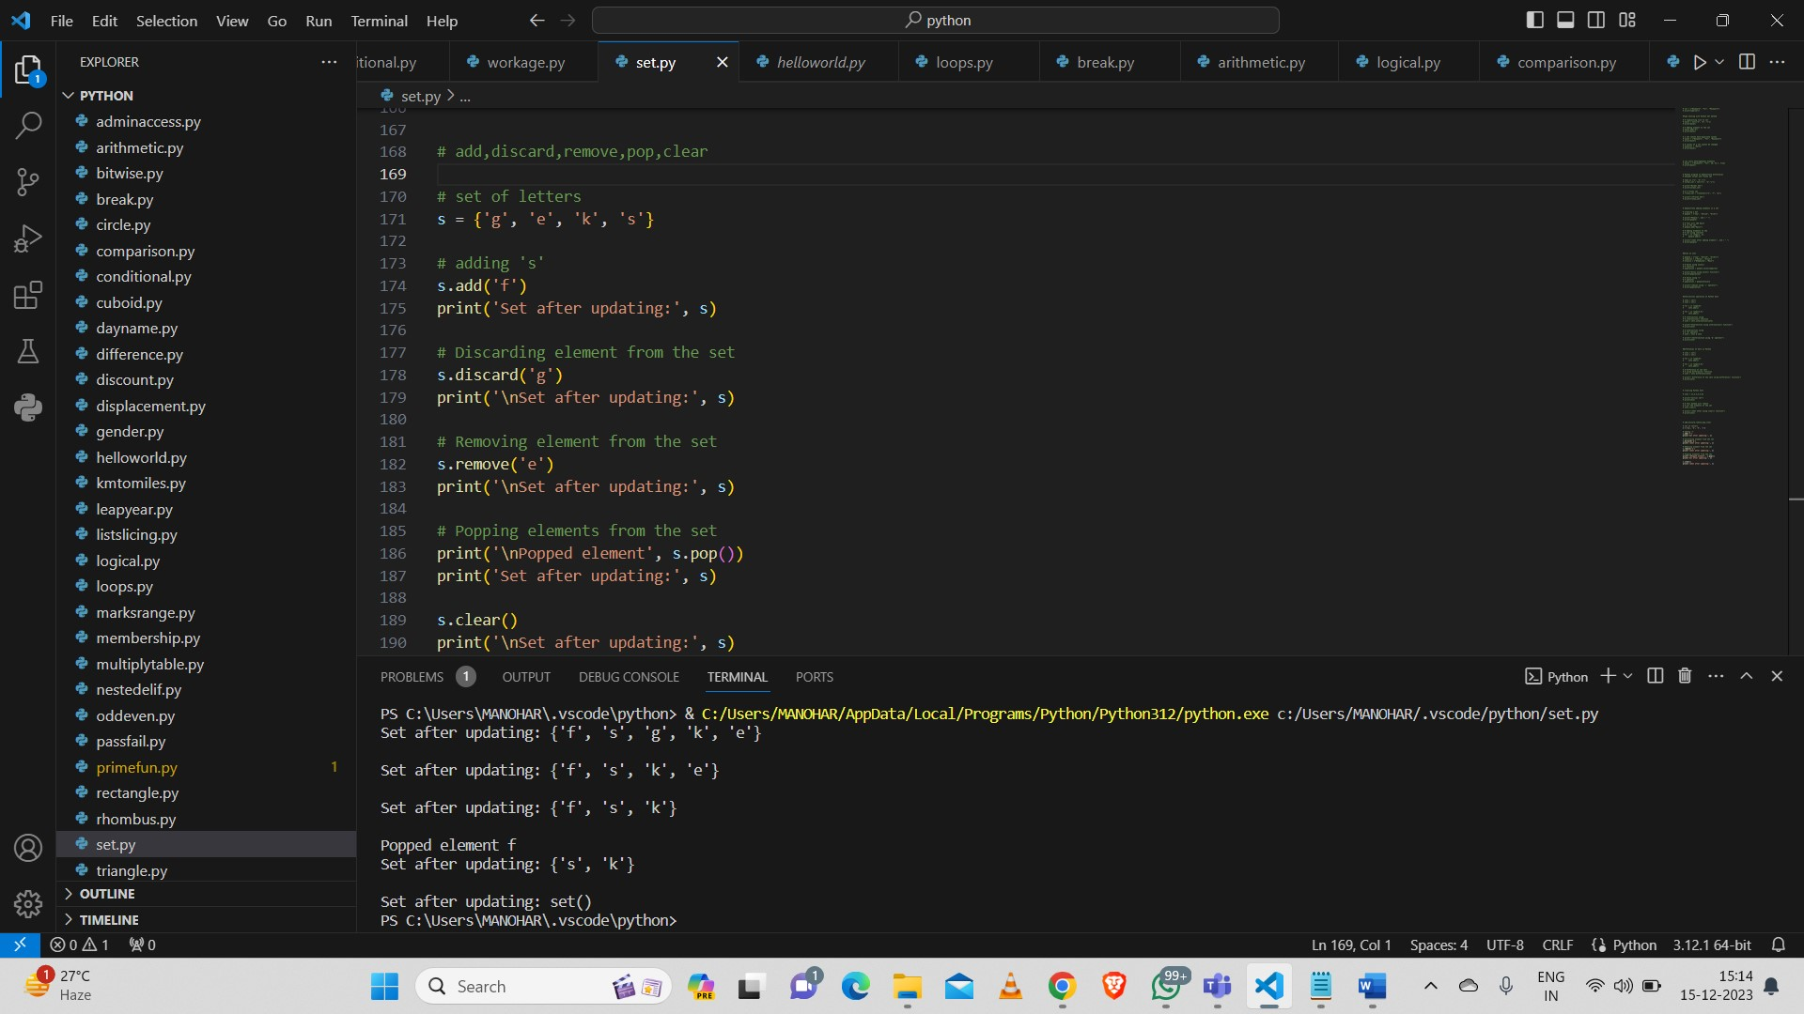

**Update:**

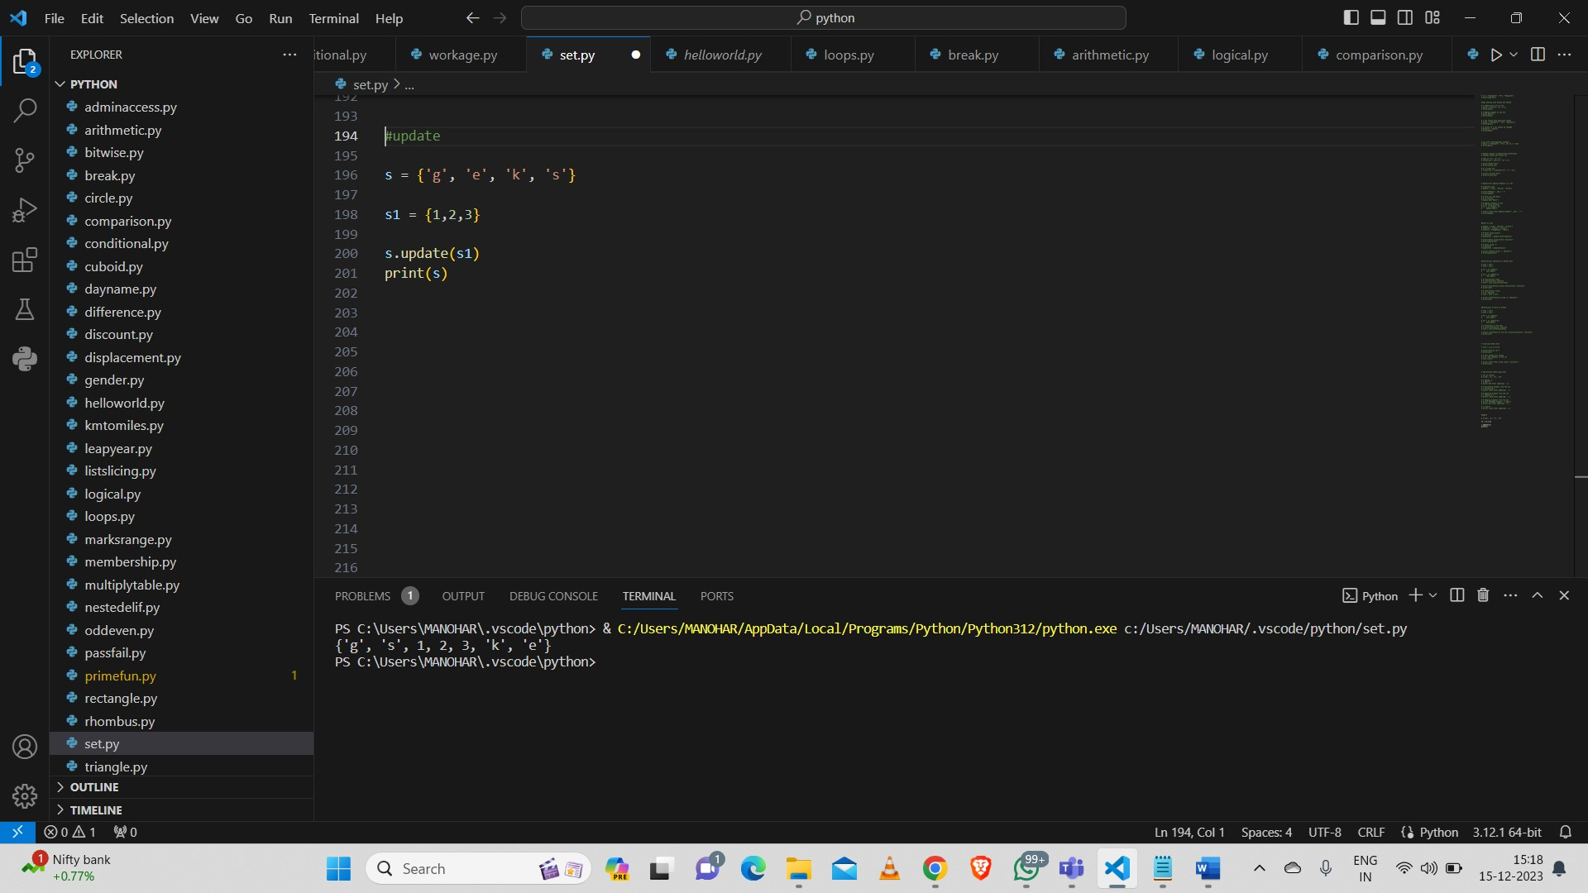

**Functions:**

Program for Prime or Not:

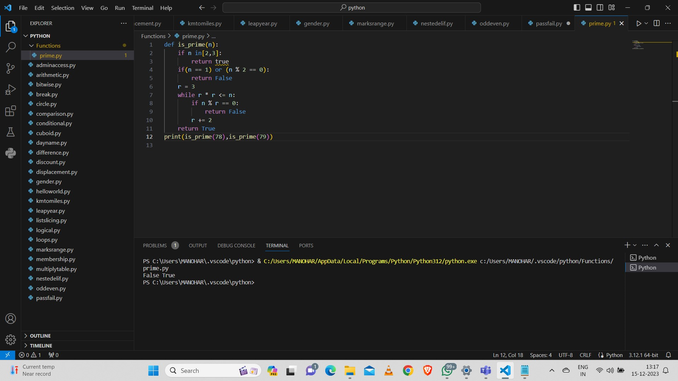

**String Functions:**

**Capitalize (),Lower(),Upper(),Isalnum(), Isalpha(),Count(), Replace(), Even or odd():**

